**Journey of food**

Chicken breast is the food I am going to research about.

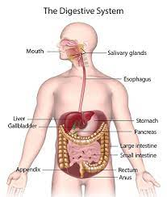

**Mouth and Oesophagus**

The digestive system consists of the digestive tract and its ancillary organs, which convert food into molecules that may be absorbed and used by the body's cells. Bit by bit, food is broken down until the molecules are tiny enough to be absorbed and waste materials are removed. Even though chickens pick up food with their beaks, it enters the digestive system through the mouth. The mouth contains glands and enzymes. The salivary glands secrete saliva, which contains the digesting enzyme amylase, which begins to digest the meal upon contact. The crop is a significant dilatation of the oesophagus positioned immediately before it reaches the thoracic cavity. The crop can store food for a period before further digestion begins. This ability allows the bird to consume food in "meals" at regular intervals while still allowing for continuous digesting.

**Stomach**

A chicken breast is mostly protein with a little fat. This enzyme primarily digests protein in the stomach. This enzyme digests fats in the small intestine. Chicken is easy to digest. It also has no fibre, making it an excellent alternative for persons suffering from digestive difficulties. Skinless chicken, baked or grilled, is the healthiest option because it contains the least fat. The time it takes for the chicken to digest in the stomach varies according to factors such as the individual's digestive health, the size of the chicken pieces, and how it was cooked. Chicken might take 2 to 6 hours to digest completely in the stomach and small intestine. The crop will bulge and feel full after a bird has eaten. The proventriculus gently absorbs food from the crop. The proventriculus combines acids and digesting enzymes with the meal. Food is next passed through the gizzard, which has accumulated insoluble (flint) grit.

**Small Intestine**

**Breakdown:** Once exiting the intestines, the chyme reaches the duodenum, the first section of the small intestine. Pancreatic juices are produced by the pancreas and bile is produced by the liver and stored in the gall bladder. Both are combined with the chyme in the small intestine. The pancreas and gall bladder both secrete enzymes and bile during this process to further break down proteins, lipids, and carbs into smaller molecules that can potentially be absorbed by the intestinal wall. Amino acids are formed when proteins are broken down and are subsequently used by the body for a variety of processes such as protein synthesis and tissue maintenance. When fats are broken down, fatty acids and glycerol are generated, which can be used to produce energy or stored in adipose tissue. When carbs are broken down, glucose, the body's major energy source, is created. The fluid chyme passes into the jejunum and subsequently the ileum of the small intestine, where most of the water and nutrients, such as glucose and amino acids, are absorbed.

**Absorption:** Digestion is finished at this point. The small intestinal lining is coated with finger-like projections known as villi, which include even smaller projections known as microvilli. These characteristics enhance the surface area of the small intestine, allowing for more effective nutrition absorption. The nutrients are absorbed via both passive and active transport pathways. Different nutrients are transported through various mechanisms; for example, fatty acids are transported passively, whereas glucose and amino acids are transported vigorously. All nutrients are distributed by the body after passing through capillaries and the circulation. Any compounds that the small intestine did not absorb are sent to the large intestine. The chyme will often remain in the small intestine for 2 to 6 hours.

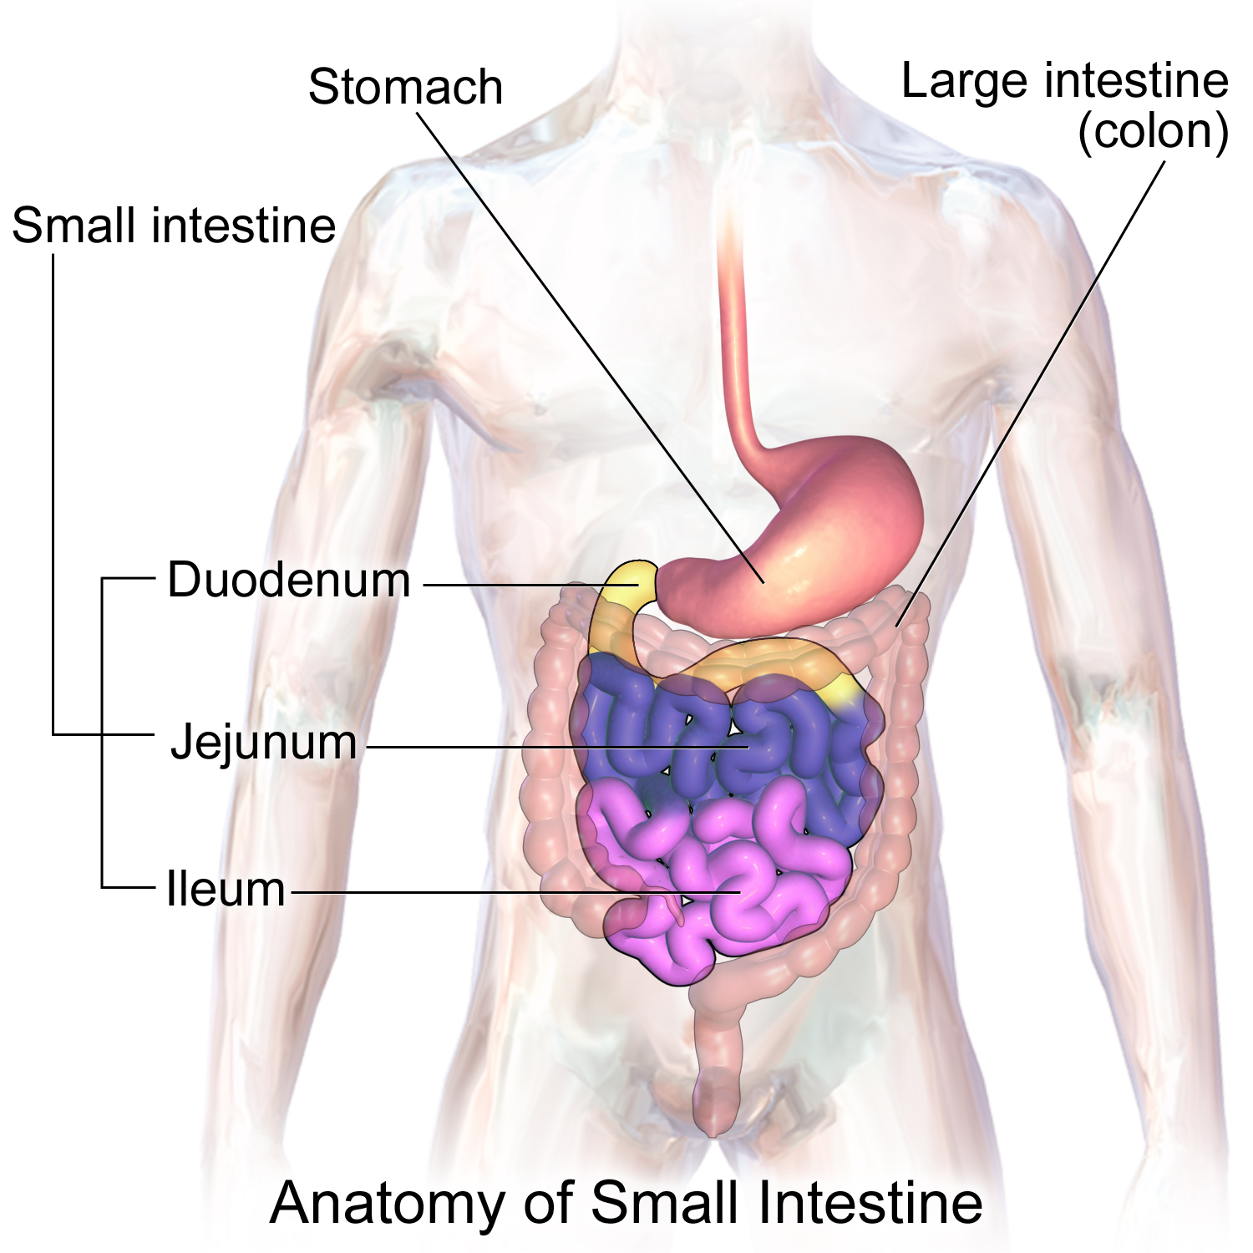

**Material Breakdown and Use:**

Chicken breast breaks down into a number of chemicals during the digestive process. Amino acids, which are formed during the breakdown of proteins, are required for the synthesis of new proteins as well as tissue upkeep. When fats are broken down, fatty acids and glycerol are generated, which can be used to produce energy or stored in fat tissue. When carbs are broken down, glucose is created, or carbohydrates can be stored as glycogen in the liver and muscles. Aside from these macronutrients, chicken breast provides vitamins and minerals that are essential in a variety of functions, like iron and vitamin B12.

**Large Intestine:**

As particles that remain pass through the large intestine, water is reabsorbed, assisting in the creation of solid faeces. Furthermore, the large intestine absorbs minerals such as salt, potassium, and chloride, which are necessary for the body's fluid equilibrium. Furthermore, bacteria in the colon produce and absorb a variety of vitamins, including vitamin K and the B vitamins. Colon bacteria play a critical function in the breakdown of chemicals that were not digested in the small intestine. They degrade fibres and other difficult-to-digest carbohydrates, resulting in short-chain fatty acids that can be turned to energy. Bacteria in the colon produce gases such as methane and hydrogen, which can exit the body through farts. The waste will last a long time.

**Elimination and faeces:**

The digestive process concludes with elimination. The compressed waste is transferred from the large intestine to the rectum as faeces at this stage. The rectum, or end of the large intestine, is where faeces are stored until they exit the body through the anus, the external hole at the end of the rectum. Faeces are made up of unabsorbed water, undigested food, bacteria, residual bile components, and cellular waste.

References:

* *Introduction to the Digestive System | SEER Training*. (n.d.). Training.seer.cancer.gov. <https://training.seer.cancer.gov/anatomy/digestive/#:~:text=The%20digestive%20system%20includes%20the>
* Cyprus. (2019, September 1). *The digestive system: The anatomy and physiology of the Chicken*. Backyard Chickens - Learn How to Raise Chickens. Retrieved May 8, 2023, from <https://www.backyardchickens.com/articles/the-anatomy-and-physiology-of-the-chicken.74728/page/the-digestive-system.15/#:~:text=Although%20chickens%20pick%20up%20feed,digest%20the%20feed%20upon%20contact>.
* *Digestive system*. Poultry Hub Australia. (2020, June 10). <https://www.poultryhub.org/anatomy-and-physiology/body-systems/digestive-system#:~:text=The%20crop%20is%20a%20large%20dilation%20of%20the,%E2%80%9Cmeals%E2%80%9D%20at%20time%20intervals%20but%20permits%20continuous%20digestion>.
* *NCI Dictionary of Cancer terms*. National Cancer Institute. (n.d.). <https://www.cancer.gov/publications/dictionaries/cancer-terms/def/small-intestine>

‌